MEMT 201 HW #12– Polymer Deformation

1. In your own words, briefly describe the phenomenon of viscoelasticity
Viscoelasticity is a property that some materials under stress show after their load has been removed. The property is sensitive to the amount of time the object was under stress. Viscoelastic materials slowly return to their original shape once load is removed.

2. You have a viscoelastic polymer with stress relaxation behavior that is characterized by the following equation;

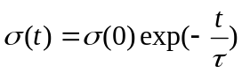

where,

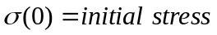,

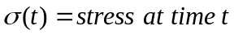,

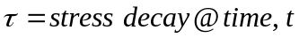

At time t = 0, stress is 3.5 MPa.

At time t = 30 s, stress is at 0.5 MPa

For an initial strain ε(0) = 0.5, what is Er(10) =?

Based on the equation:
τ = -t / ln(σ(t) / σ(0))
Given t = 30 s

τ = -(30) / ln(σ(30) / σ(0)) = -30 / ln(0.5 / 3.5) = 15.42 s

σ(10) = σ(0) exp(-t / τ) = 3.5 MPa exp ( -10 s / 15.42 s ) = 1.830 MPa

E_{r}(t) = σ(t) / ε(0) = σ(10) / ε(0) = 1.830 MPa / 0.5 = 3.660 MPa

